Fig. 1. Average peak areas (n=3) for 10 µg L⁻¹ BrO₃⁻
at varying pH of the mobile phase.

oven temperature, ºC

Fig. 2. Average peak areas (n=3) and retention times (n=3) for
10 µg L⁻¹ BrO₃⁻ at varying oven temperatures in ºC.

Fig. 3. Comparison of inorganic anions [(A): HCO₃⁻, Cl⁻, NO₃⁻; (B): SO₄²⁻, Br⁻, F⁻; (C): NO₂⁻, PO₄³⁻, ClO₃⁻] at different concentrations spiked in ultrapure water containing
10 µg L⁻¹ BrO₃⁻ and ultrapure water containing 10 µg L⁻¹ BrO₃⁻ only.
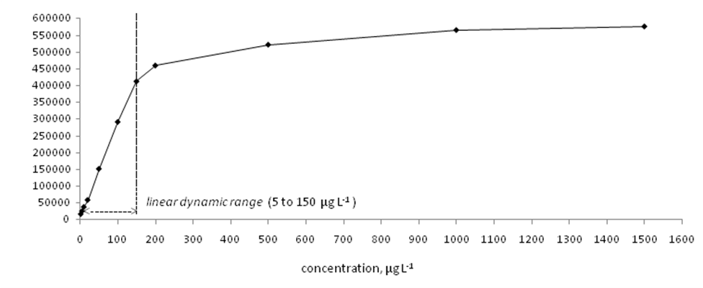
Fig. 4. Graphical representation of the peak area response of 2 to 1500 µg L⁻¹ BrO₃⁻ (n=3) in ultrapure water showing linear dynamic range.

Fig. 5. A linear calibration graph for 2 to 150 µg L⁻¹ BrO₃⁻ solutions (n=3) using the optimized ion chromatographic method. [Solid line represents linear regression and dotted lines show 95 % confidence interval levels about the regression.]

