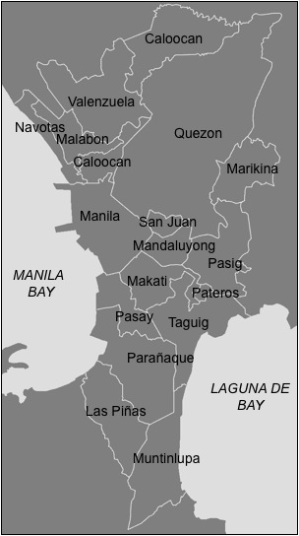
Figure 1. Map of Metropolitan Manila showing the sixteen cities and one municipality comprising the metropolitan area.

